

January 7, 2015

Re: NPA 629 to Overlay NPA 615 (Tennessee)

Dear Customer,

On October 23, 2013, the Tennessee Regulatory Authority (TRA) in its order in Docket No.
11-00018 approved an all services overlay as the relief method for the 615 NPA. The 615 NPA
covers the north-central portion of the state of Tennessee serving communities such as Franklin,
Gallatin, Hendersonville, Lebanon, Murfreesboro, Nashville and Springfield. The new 629 NPA
will serve the same geographic area currently served by the existing 615 NPA.

Implementation of Relief Plan
Implementation of the overlay of the 629 NPA is as follows:
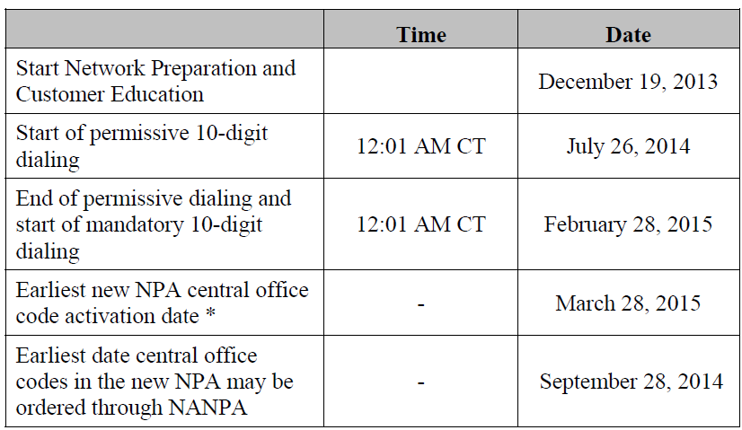
* Effective Date of the New 629 NPA

During the permissive dialing period, subscribers may dial local calls within the overlay area on
either a 7-digit or 10-digit basis, but will be encouraged to dial 10-digits. After the permissive
period ends, all calls must be dialed using 10-digits.

PHASE I
Permissive Dialing Date –Began July 26, 2014: During the permissive dialing period, subscribers may dial local calls within the overlay area on either a 7-digit or 10-digit basis, but will be encouraged to dial 10-digits. After the permissive period ends, all calls must be dialed using 10-digits.
When preparing for overlay area code relief, carriers are strongly encouraged to prepare their switches to begin sending 10 digits prior to the mandatory 10-digit dialing conversion date for customers.

PHASE II
Mandatory 10 Digit Dialing Date – Begins February 28, 2015: All callers must dial local calls with 10 digits. If you inadvertently dial 7 digits, your call will not be completed and a recording will prompt you to hang up and dial again.

Dialing Plan
Coincident with the introduction of mandatory 10-digit dialing, the dialing plan for the 615 and
629 NPAs will be as follows:
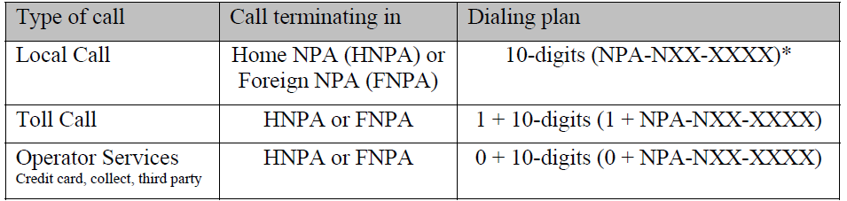
*1+10 digit permissible at service provider’s discretion

To prepare for this overlay, please note the following:

- Notify your clients, vendors, domestic and international of your new area code.
- Inform employees, customers, and co-workers.
- Changes in telephone equipment should be directed to the equipment vendor.
- Utilize the applicable test number to make sure your equipment recognizes the new area code.
- Update all correspondence, such as stationery, business cards, checks, brochures, promotional items, internet web pages, catalogs, directory listings.
- Reprogram features such as Auto-Dialing, Speed dialing, and Call Forwarding.
- Reprogram security doors and gate systems.
- Contact your service provider to update your cell phone and other wireless communications.
- Internet dial-up connection may need reprogramming or upgraded.
- Notify Alarm system providers of the new area code + telephone number so they can update their records and equipment as needed.

The area code overlay will not affect the cost of a call. Costs incurred for updating systems and revising printed materials is the responsibility of the customer. The directory listings (white pages) will be updated by the telecommunications industry. Listings appearing in other directories will be the responsibility of the customer.

If you have any additional questions, please contact your Premier Specialist or Customer Service 1-866-847-5500.

